DEBATE SCORE SHEET

FORMAT -

* Conventional Debate
* Turncoat Debate

Motion -

Name of Adjudicator -

Scoring Parameters -

Matter - 10 marks, Manner - 5 marks, Method - 10 marks

| S.No. | Name | Side/ Stance (For or Against) | Total Score (25) |
| --- | --- | --- | --- |
|  |  |  |  |
|  |  |  |  |
|  |  |  |  |
|  |  |  |  |
|  |  |  |  |
|  |  |  |  |
|  |  |  |  |
|  |  |  |  |
|  |  |  |  |
|  |  |  |  |
|  |  |  |  |
|  |  |  |  |
|  |  |  |  |
|  |  |  |  |

DEBATE SCORE SHEET

FORMAT - Asian Parliamentary Debate

Motion -

Team on side govt -

Team on side opposition -

Motion vetoed by govt -

Motion vetoed by opp

Name of Adjudicator -

SCORING RANGE -

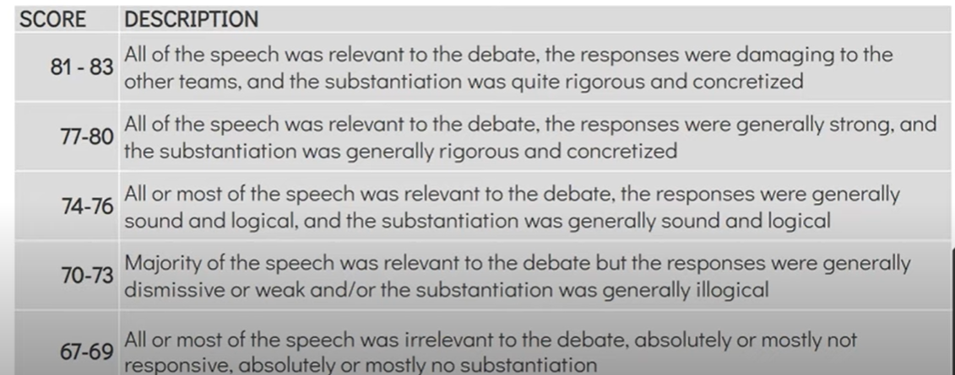

| Speaker role | Name | score |
| --- | --- | --- |
| Prime Minister |  |  |
| Deputy Prime Minister |  |  |
| Govt Whip |  |  |
| Govt Reply |  |  |
| Total govt score |  |  |
|  |  |  |
| Leader of Opposition |  |  |
| Deputy Leader of Opposition |  |  |
| Opp Whip |  |  |
| Opp Reply |  |  |
| Total opp score |  |  |
|  |  |  |
|  |  |  |
|  |  |  |